**MANUAL USER: PWV APPLICATION SOFTWARE**

By Dr Sam Vennin

King’s College London

[Samuel.vennin@kcl.ac.uk](mailto:Samuel.vennin@kcl.ac.uk)

3 October 2022

Table of Contents

1. Summary 3

2. Pulse wave velocity 3

3. Requirements 4

4. Path length windows 5

a. Parasagittal scan mode 5

b. Axial scan selection 7

c. 3D scan window 10

5. Transit time and flow analysis window 14

a. Ascending-Descending flow waves 14

b. Ascending-Descending-Diaphragm flow waves 15

Reference 16

# **Summary**

The present software has been developed to assess various haemodynamic parameters from different MRI scan modes and store them in Excel spreadsheets.

Types of MRI scans that can be used:

* Axial scans
* Parasagittal scans
* Coronal scans

Variables derived by the software:

* Aortic flow waveform analysis
  + Stroke volume (SV)
  + Heart rate (HR)
  + Cardiac output (CO)
  + End-diastolic volume (EDV)
  + Ejection fraction (EF)
  + First phase ejection fraction (EF1)
* Pulse wave velocity (between the ascending and descending aorta, descending aorta and diaphragm level, and between the ascending aorta and diaphragm levels)
  + Transit time (TT)
  + Path length (L)
  + Pulse wave velocity (PWV)
* Arterial distensibility
  + Ascending aorta location
  + Descending aorta location
  + Diaphragm level
* Left ventricular elastance (if blood pressure information is inputted)
  + Elastance at the onset of ejection (End)
  + Elastance at end systole (Ees)

# **Pulse wave velocity**

Pulse wave velocity (PWV) is the speed at which the blood wave travels along arteries. As such, it requires two components for calculations: the distance travelled (path length, L) and time taken to travel this path (transit time TT). We hence have:

Calculations in this software can hence be broken down into two parts: one to calculate the pathlength from the MRI scans, and another to compute the transit time from the flow waves through the Flow Analyser window.

# **Requirements**

This application runs on Matlab (The MathWorks, Natick, MA), preferably in a Window/Apple/Linux environment. Please ensure the *Image Processing Toolbox* and *Signal Processing Toolbox* packages are uploaded. To do so, click on the “Get More Apps” button as below (red square).

This will open a window as below in which users must input the name of the toolboxes they want to download in the “Search for add-on” tab (red arrow).

Users should then follow instructions and not be surprised if the programme ask you to close the Matlab window.

Please note that Matlab unfortunately does not save the layout of the windown from one machine to another. As such, it is possible that panels and fields in some windows are misplaced or misaligned on the users’ machine. If that happens, users should type in the command window *guide* followed by the name of the *.fig* file (e.g., *guide GUI_main.fig*) and move fields around to fit the setup of their computer.

# **Mode window**

Open the file *GUI_main.m* in Matlab and click on the *Run* button on the top bar. Upon launching, the hereunder main menu window will open asking the user to select which type of MRI sequences they will use to calculate path length (hence PWV - transit time will be calculated within the path length window) or to move on to the LA/LV coupling mode.

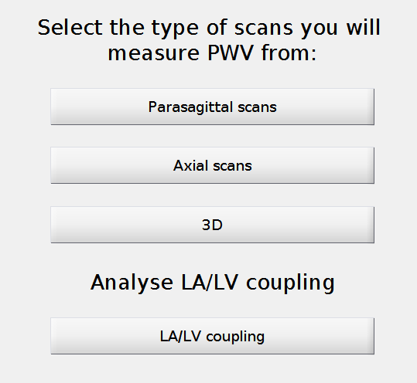

# **Pulse wave velocity calculations**

## **Parasagittal scan mode**

If the parasagittal scan option has been selected, the window below will open:

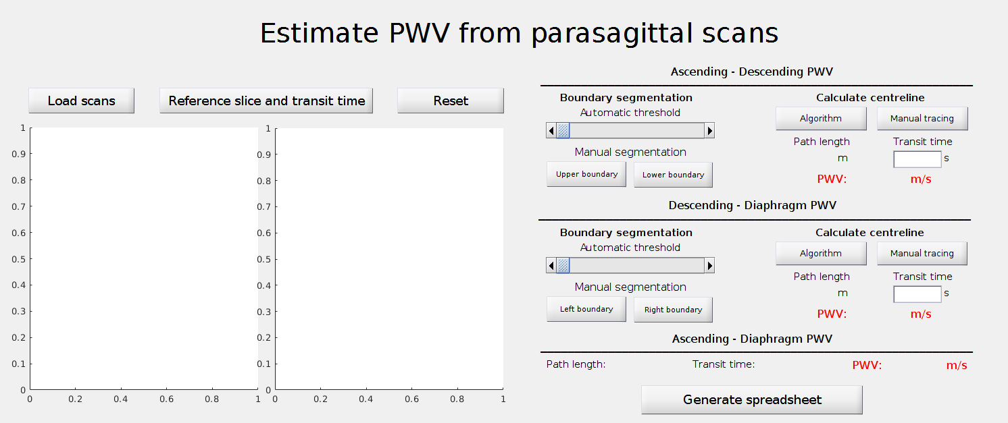

The user first needs to load the parasagittal scans by selecting the folder containing them, and then to select the spreadsheet containing the flow waveforms (this file must be in the folder containing the axial slices used to extract them). The flow analysis window will open (see 5). If the software detects a flow waveform extracted at the diaphragm level, it will prompt the user to select an axial slice from which these were extracted. This is done for positioning purpose: these slices contain the location at which they were acquired. These reference lines appear in white on the window.

Now that transit times have been calculated and the corresponding slices located, we can calculate the path length. There are different methods for calculating it.

1. We recommend users to select the “Manual tracing” option. They then directly draw the path length you want to consider in the right panel. In the top section of the aorta, they can start or end the drawing below the reference slice and the algorithm will only retain the path above. The same process will apply to the descending-diaphragm section.

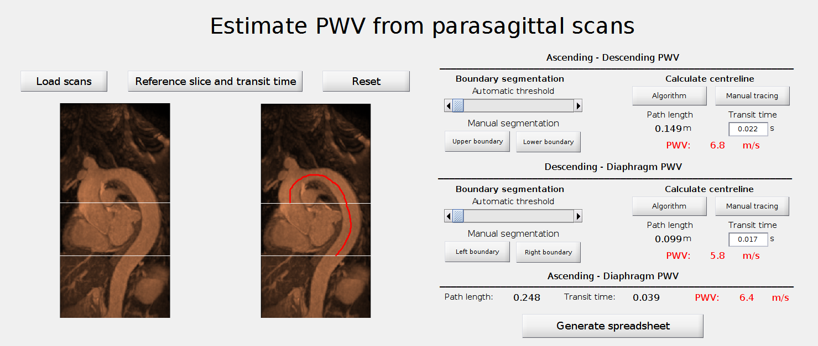

1. Another possibility is to move the automatic threshold slider until the boundaries of the upper aorta or the lower aorta are selected. Once this is the case, users should select the *Algorithm* button and the path length will be automatically calculated. The pathlength is hence defined as the middle points between boundaries. Beware though that the optimal strategy for thresholding and extracting the boundaries is still under development and we recommend users not to use this function.
2. The last possibility is to manually draw the boundaries of the aorta (by selecting the the *Upper boundary* and the *Lower boundary* buttons to draw the boundaries of the top of the aorta, on the *Left boundary* and *Right boundary* buttons to draw the boundaries of the descending aorta-diaphragm portion of the scan), and then to click the Algorithm button to calculate the path length. The pathlength is hence defined as the middle points between boundaries.

Once all metrics have been calculated, users can click on the “Generate spreadsheet” button to save all relevant information in an excel spreadsheet.

## **Axial scan selection**

When the Axial scan is selected, the following window will open:

Upon selecting the *Load files* button, the user will need to sequentially:

1. Select the file containing the flow waveform spreadsheets that MUST be in the folder containing the axial slices from where the waveforms were extracted.
2. If the software detects that a flow waveform was also acquired at the diaphragm level, it will then request to select a slice from the folder containing the axial slices used to extract it. Otherwise, it will proceed directly to the flow analysis waveform window (see 5).
3. Finally, the user needs to select the folder containing all axial slices.

Once all temporal information from flow waves have been extracted and all slices have been loaded, the user needs to identify the ascending and descending aorta on the slice that has been used to extract the flow waveforms at these locations. It can be either performed automatically or manually. In the latter case, the user will have to draw circles around both luminal areas. Depending on scan quality and ease for identifying the luminal areas, the user can then either choose to continue with the automatic or the manual mode.

* Automatic mode

The software extracts all relevant luminal areas: firstly, from the ascending-descending aorta reference slice down to the diaphragm reference slide; secondly, upward from the ascending-descending aorta reference slice until it cannot detect luminal areas anymore as slices start to cut through the top of the aortic arch. Then, two possibilities are offered to the user to measure the path length at the top of the aortic arch: by interpolation from existing data points or by extraction of the top of the aortic arch from a parasagittal scan.

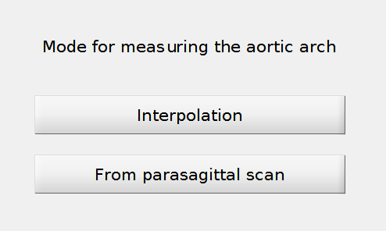

The parasagittal extraction functions as in the parasagittal mode described earlier (a). Once satisfied with the path length, users can extract it and merge it with already extracted data points from the axial scans.

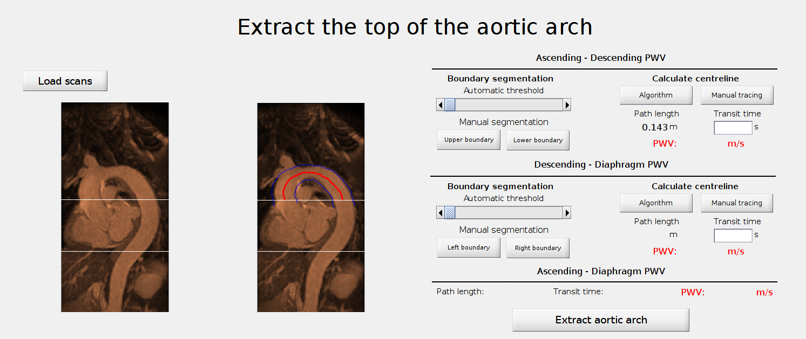

* Manual mode

In this mode, users need to repeat the previous stage for all slices acquired, firstly from the ascending/descending aorta slice from where the waveforms were acquired down to the diaphragm level, and secondly from the ascending/descending aorta slice up to the top of the arch. To move on to the next slice, they should press the “Yes” button. In the first stage, as slices move downwards and the ascending aorta starts confounding with the heart, users can decide to stop the selection of the ascending aorta by pressing the *Forego ascending aorta* button.

In the second stage, users can decide, once slices cut through the top of the aortic arch and the ascending and descending aorta’s luminal areas can no longer be identified, to directly move on to the extrapolation of the top aortic arch by pressing the *Move on* button or extracting it from parasagittal scans and fusing it with the axial slices as described in the Automatic mode.

Once the aortic path length has been acquired, the software will combine it with the transit time to derive PWV of the selected segments. Users can save all information as an Excel spreadsheet.

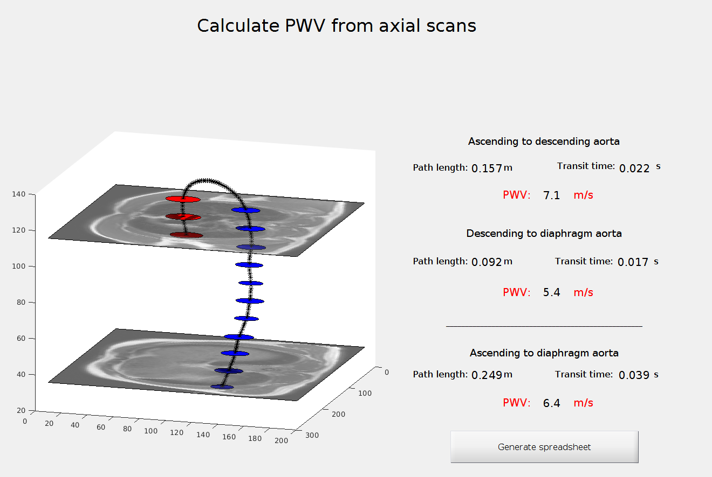

## **3D scan window**

The 3D mode work similarly to the Axial scan mode, with the notable difference that instead of interpolating the top of the aortic arch or extracting it from a parasagittal scan, an extra data point is extracted from a transverse slice. This allows the extraction of a reference point for the top of the ascending arch.

When selected, the 3D scan mode will open this window:

Upon selecting the “Load files” button, the user will need to sequentially:

1. Select the file containing the flow waveform spreadsheets that MUST be in the folder containing the axial slices from where the waveforms were extracted.
2. If the software detects that a flow waveform was also acquired at the diaphragm level, it will then request to select a slice from the folder containing the axial slices used to extract it. Otherwise, it will proceed directly to the flow analysis waveform (see 5).
3. Finally, users need to select the folder containing all coronal slices.

Once all temporal information from flow waves have been extracted and all slices been loaded, users have to identify the ascending and descending aorta on the slice that has been used to extract the flow waveforms at these locations. It can be performed either automatically or manually. In the latter case, the user will have to draw circles around both luminal areas. Depending on scan quality and ease for identifying the luminal areas, users can then either chose to continue with the automatic or the manual mode.

* Automatic mode

The software extracts all relevant luminal areas except for the top of the aortic arch. A window then opens to select the vessel at the top of the aortic arch from a transverse slice (see hereunder).

* Manual mode

Users repeat the previous stage for all slices acquired, firstly from the ascending/descending aorta slice from where the waveforms were acquired down to the diaphragm level, and secondly from the ascending/descending aorta slice up to the top of the arch. To move on to the next slice, they should press the *Yes* button. In the first stage, as slices move downwards and the ascending aorta confounds with the heart, users can decide to stop the selection of the ascending aorta by pressing the *Forego ascending aorta* button.

In the second stage, the user can decide once slices cut through the top of the aortic arch to directly move on to the identification of the top aortic arch by selecting the *Move on* button.

When the luminal areas of the ascending and descending aortas can no longer be segmented, the 3D mode offers to identify the vessel at the top of the arch from a transverse slice rather than interpolating a parabolic waveform or resorting to a parasagittal scan as in the Axial mode. As with other windows, users can either let the software select the luminal areas or draw the contours of the vessel themselves.

Upon pressing the *Yes* button, the software will extrapolate the rest of the waveform, calculating path lengths and computing PWV from the transit times.

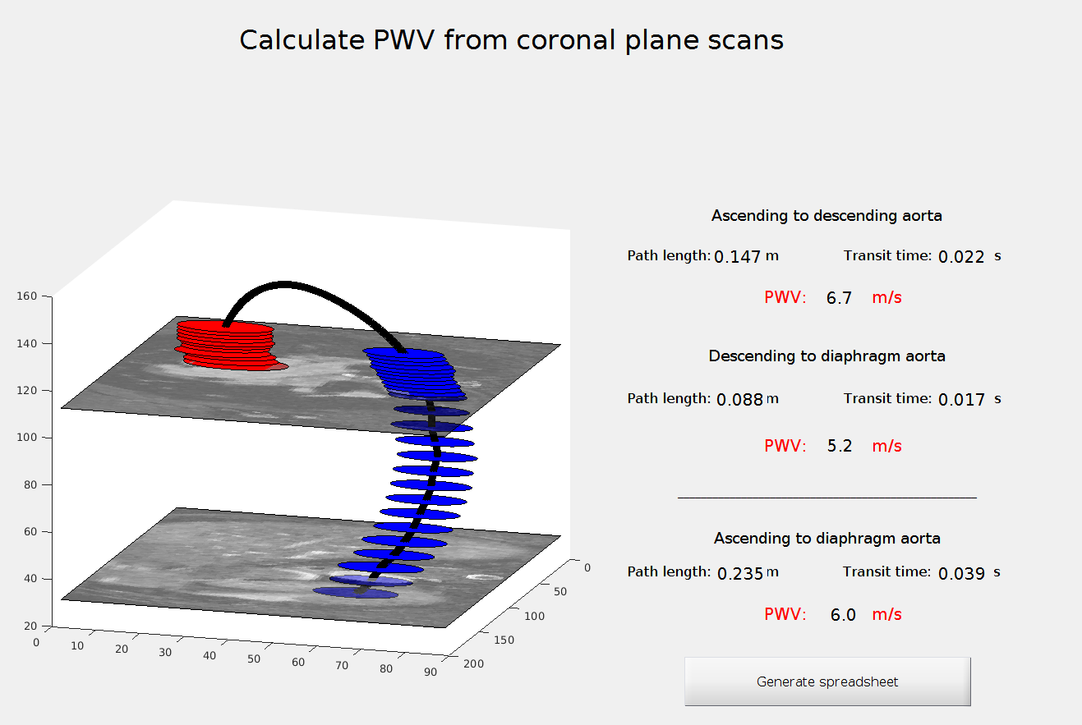

Once calculations have been performed, useres can save all measurements as an Excel spreadsheet.

# **Left Ventricular/Left Atrium coupling calculations**

# **Transit time and flow analysis window**

This window calculates various parameters related to the flow waves such as transit times through various methods (detailed in [1]).

It is important to ensure the excel spreadsheet containing all waves (outputted by the MRI scanner, no need to edit it) is placed in the folder containing the axial scans used to extract the ascending-descending flow waveforms. The application will automatically detect if there are two (ascending and descending aortas) or three (ascending, descending aorta and diaphragm) flow waves, and will open the appropriate window.

## Ascending-Descending flow waves

If there are only two flow waves, the window below will open.

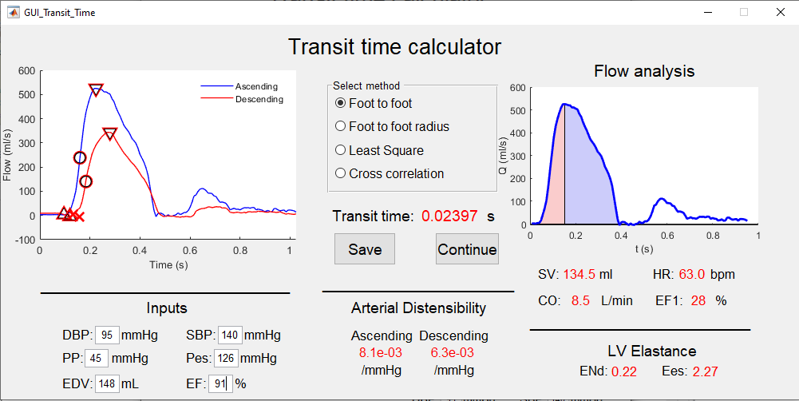

Users can choose many different methods for calculating the transit time between the ascending and descending aorta. More details on them can be found in [1], however we recommend the standard *Foot to foot* PWV as in the example above. Should one method result in an error from the software, select another.

The flow waves in the ascending and descending aortas (blue and red waves respectively) will appear in the left panel and the transit time calculated through the method selected will be displayed in red in the middle. On the right panel, only the ascending flow is displayed. The red area under the curve corresponds to the volume of blood ejected by the left ventricle until the time of peak flow and the blue area shows the blood volume ejected afterwards. Adding the two areas yields stroke volume while the ratio of the red area and stroke volume yields EF1 [2]. Finally, the Heart Rate (HR) is calculated from the flow wave and multiplying it with SV yields cardiac output (CO). All these metrics can be found under the flow wave on the right panel.

Users can also input additional metrics such as diastolic blood pressure (DBP), systolic blood pressure (SBP), pulse pressure (PP), end systolic pressure (Pes), end-diastolic volume (EDV) and ejection fraction (EF). If enough metrics are provided, the software will automatically compute other variables linked to them. For example, when users type in DBP and PP, the computer will automatically compute SBP and Pes (=0.9*SBP). Similarly, entering a value for EF will immediately display EDV. These variables will be used to assess distensibility at the ascending and descending aorta, as well as left-ventricular (LV) elastance at the onset of ejection (ENd) and at end-systole (Ees) following [3].

Once all needed metrics have been calculated, users can press the *Save* button and a window will open offering them to generate a spreadsheet with all these metrics, or just press *Continue* to move to the next stage of calculation. In both cases, all these variables will be stored and included in the final spreadsheet users will have the possibility to generate at the end of all calculations.

## Ascending-Descending-Diaphragm flow waves

If three waves are detected, the hereunder window will open and calculate transit time between the ascending and descending aortas (top left panel), the descending aorta and the diaphragm (middle left panel) and add those two metrics to have a global ascending to diaphragm transit time (bottom left panel). The same metrics as in the previous case with just two waveforms are displayed, with the addition of distensibility of the aorta near the diaphragm.

Once needed metrics are computed, users can either press the *Save* button and a window will open offering them to generate a spreadsheet with all these metrics, or just press *Continue* to move to the next stage of calculation. In both cases, all these variables will be stored and the transit times will appear in the main PWV application window.

# Reference

[1] Gaddum, N.R., Alastruey, J., Beerbaum, P., Chowienczyk, P. and Schaeffter, T., 2013. A technical assessment of pulse wave velocity algorithms applied to non-invasive arterial waveforms. *Annals of Biomedical Engineering*, 41(12), pp.2617-2629.

[2] Gu, H., Li, Y., Fok, H., Simpson, J., Kentish, J.C., Shah, A.M. and Chowienczyk, P.J., 2017. Reduced first-phase ejection fraction and sustained myocardial wall stress in hypertensive patients with diastolic dysfunction: a manifestation of impaired shortening deactivation that links systolic to diastolic dysfunction and preserves systolic ejection fraction. *Hypertension*, *69*(4), pp.633-640.

[3] Chen, C.H., Fetics, B., Nevo, E., Rochitte, C.E., Chiou, K.R., Ding, P.A., Kawaguchi, M. and Kass, D.A., 2001. Noninvasive single-beat determination of left ventricular end-systolic elastance in humans. *Journal of the American College of Cardiology*, 38(7), pp.2028-2034.